Assesment Lap B – Nguyen Ngoc Thuong

1. Configure the IP address: 10.10.10.10

Step 1: Run [Server Manager] and select [Local Server] on the left pane and click [Ethernet] section on the right pane.

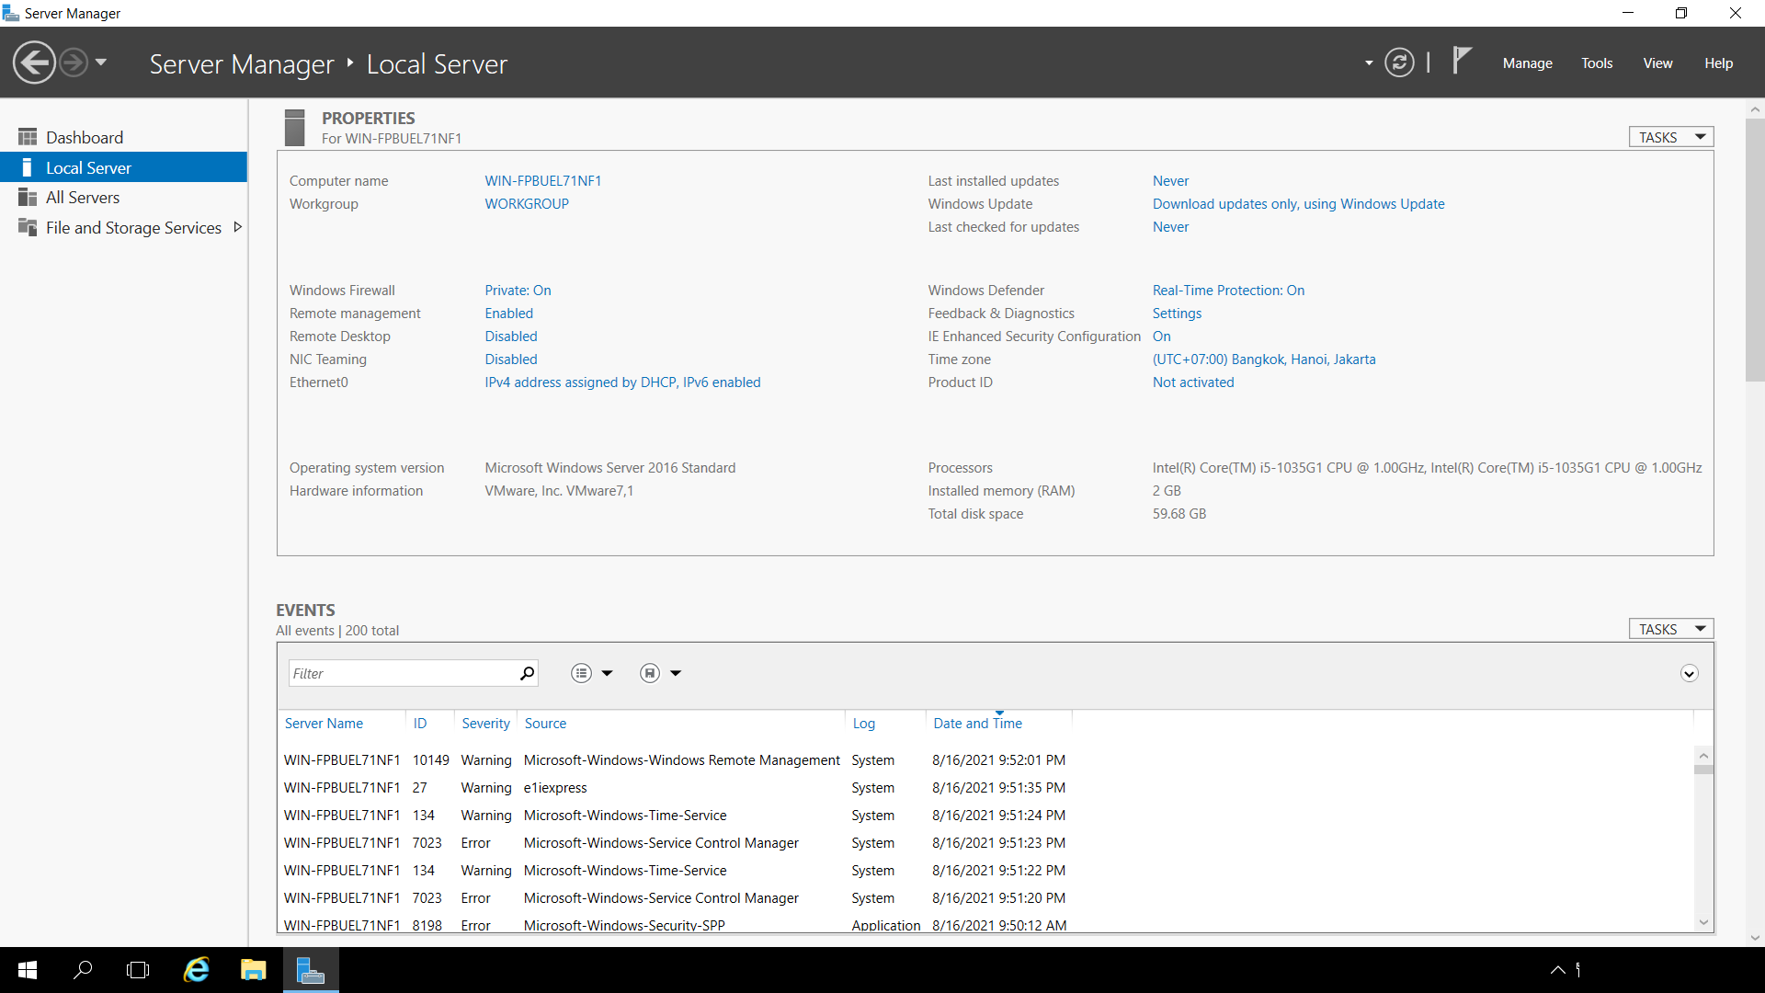

Figure 1 –

Step 2: Right-Click [Ethernet] icon and open [Properties].

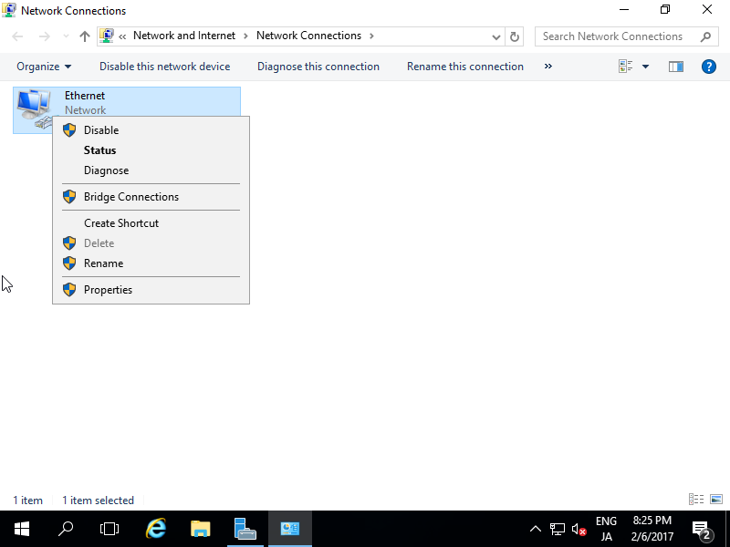

Step 3: Select [Internet Protocol Version 4] and click [Properties] button.

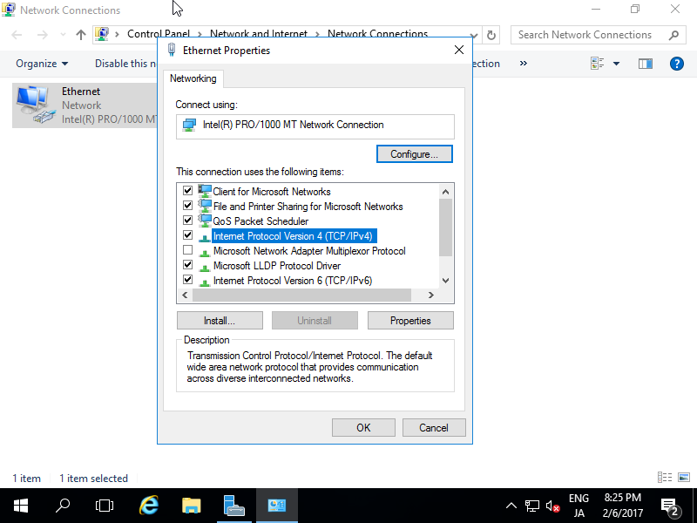

Step 4: Set Static IP address and Gateway and others for your local network.

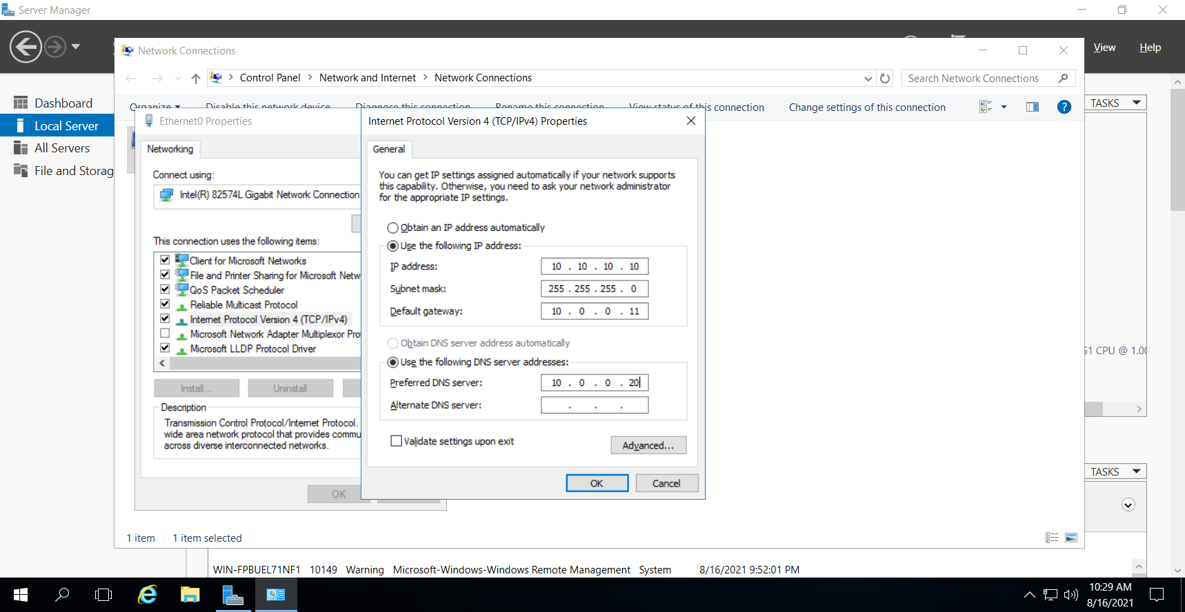

After setting static IP address, changes are enabled on Server Manager.

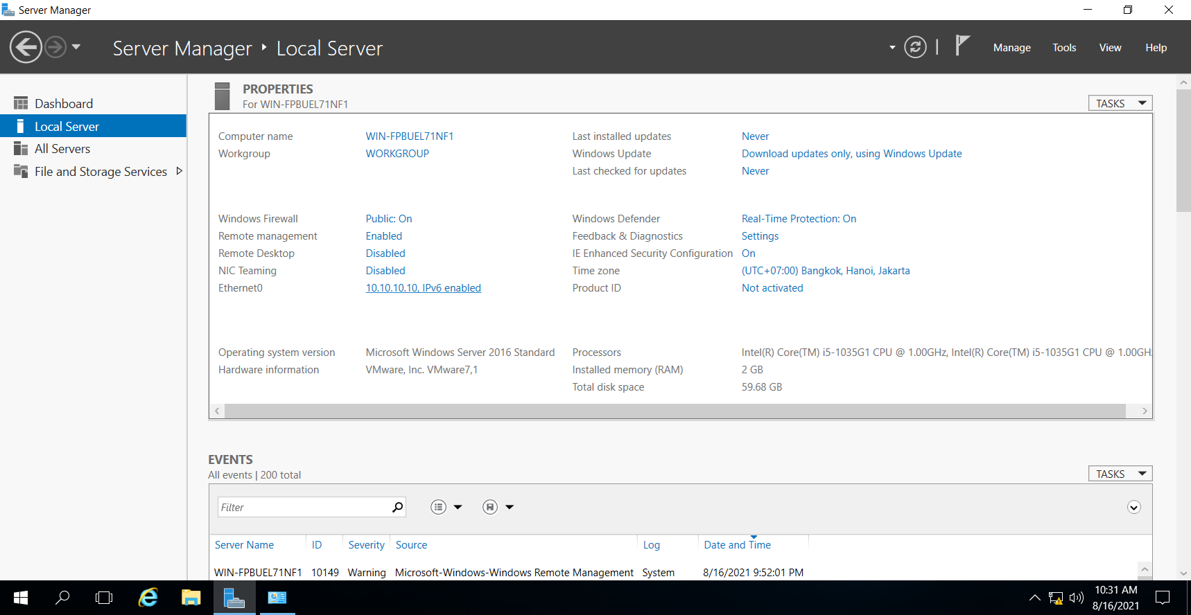

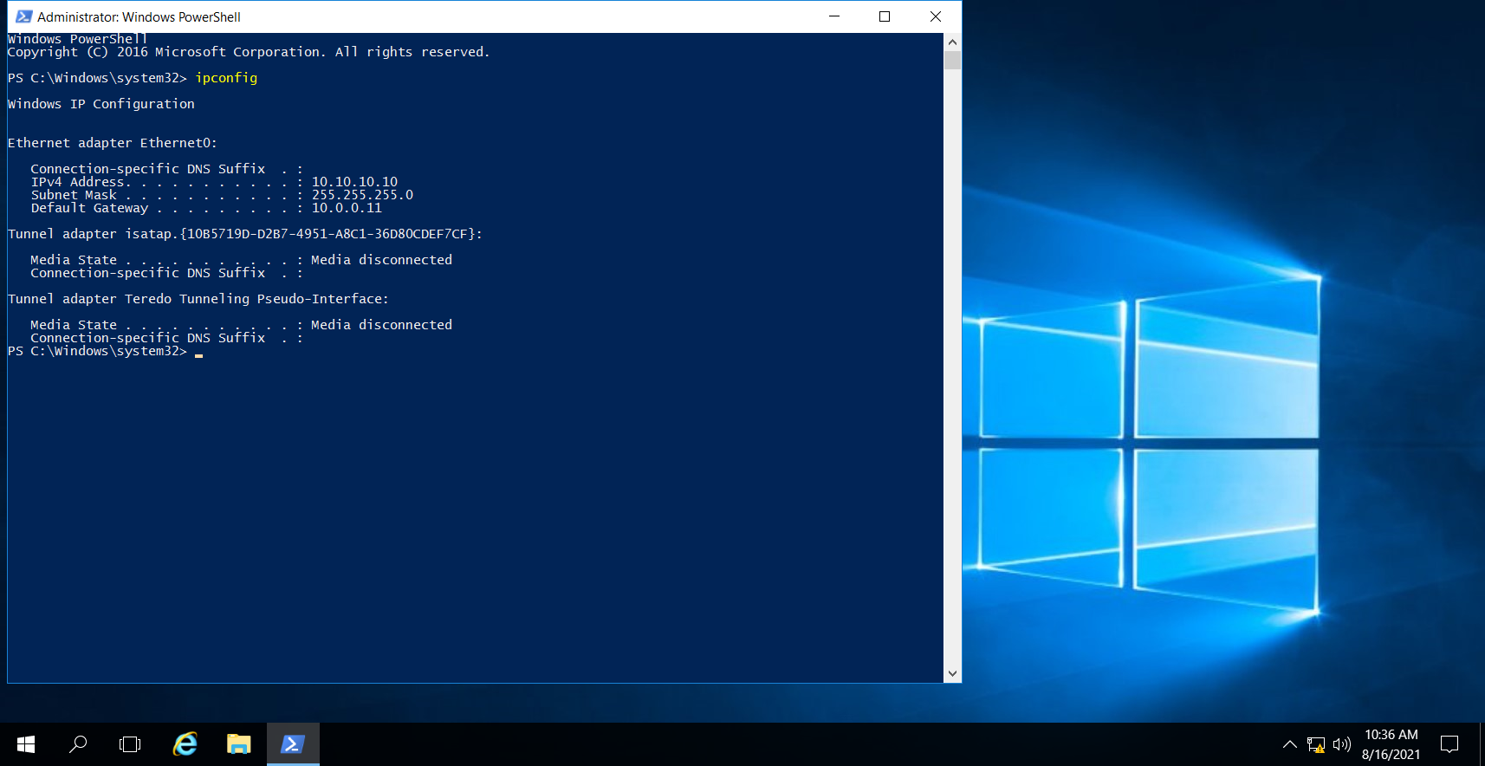

1. Set the computer name:

Step 1: Click the start menu and then click Server Manager.

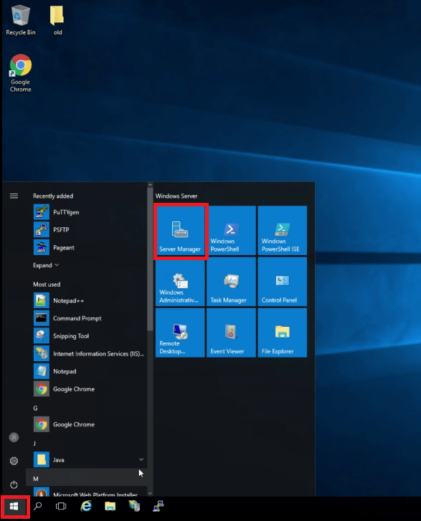

Step 2: Click local server and then your computer name.

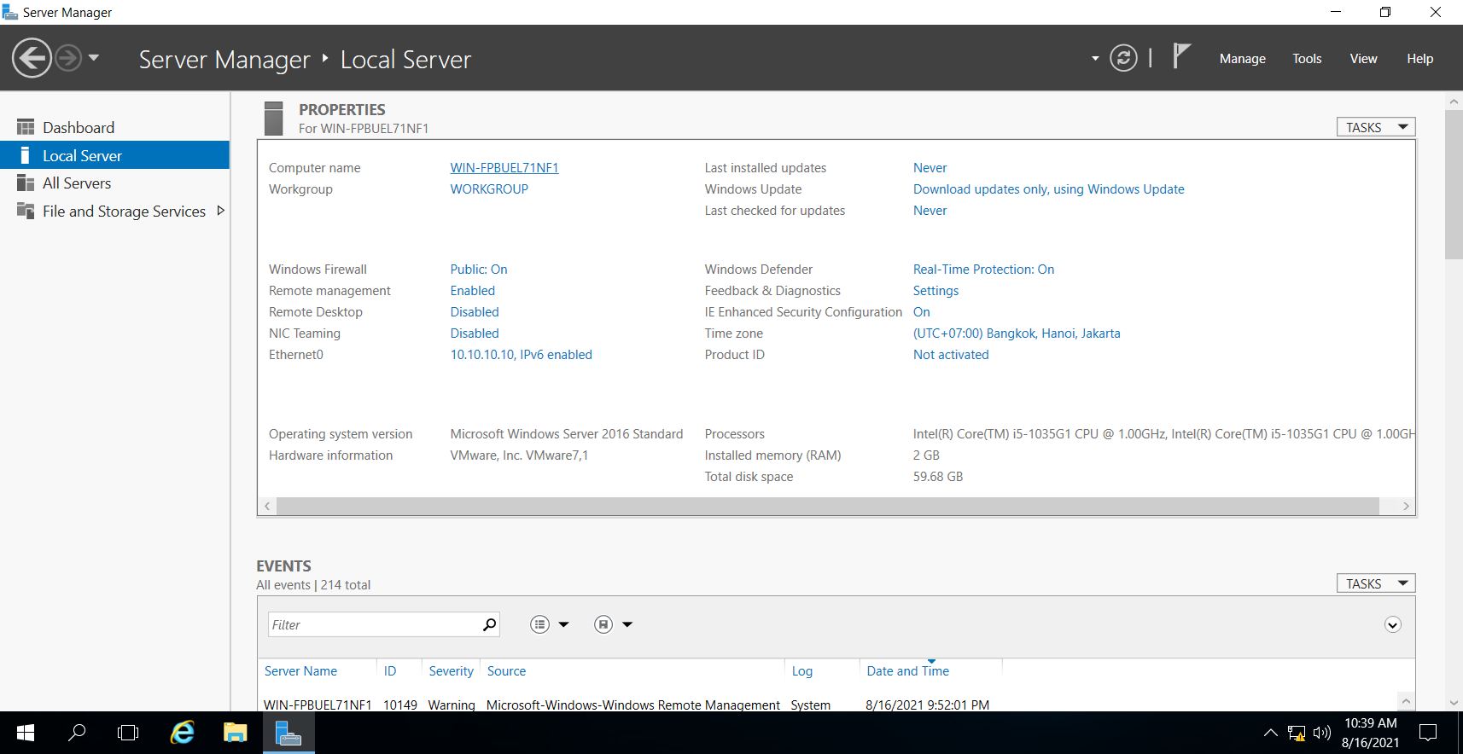

Step 3: Click Change

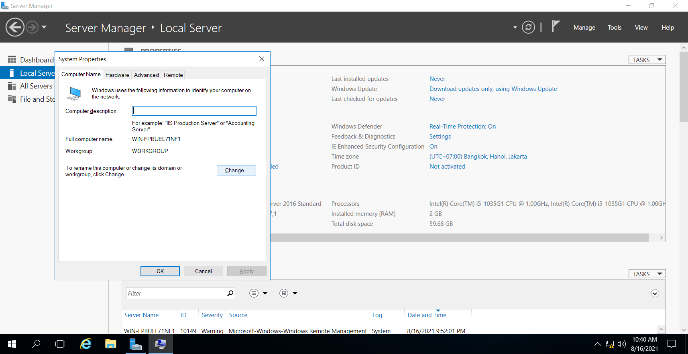

Step 4: set name SRV1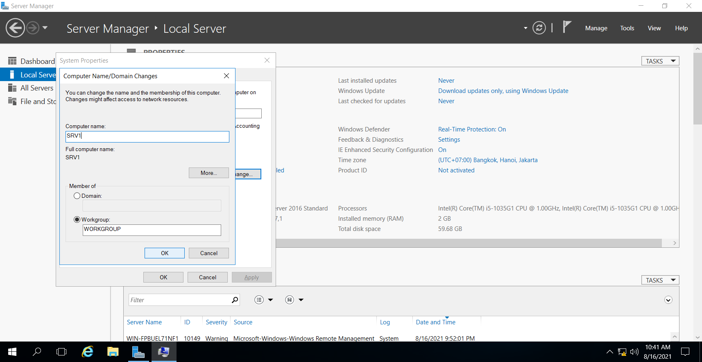

**Step 5**: Restart your computer and when the server restarts you will see that your hostname will be changed.

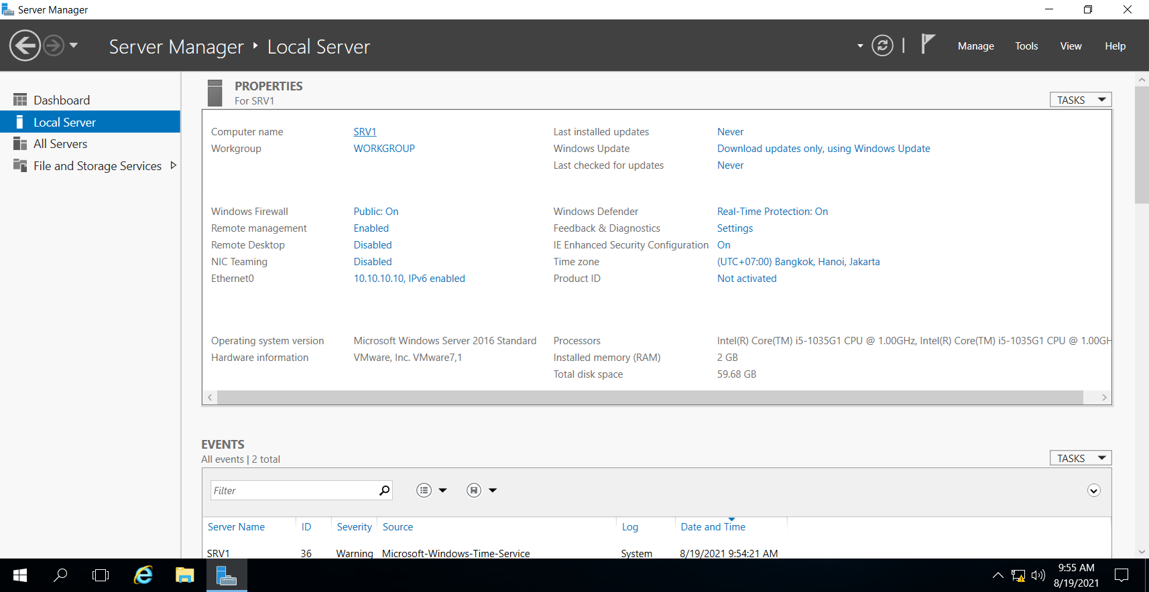

1. Configure the time zone:

Step1:

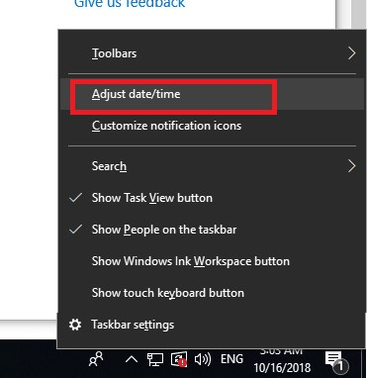

Step2: pick UTC +7:00 HaNoi

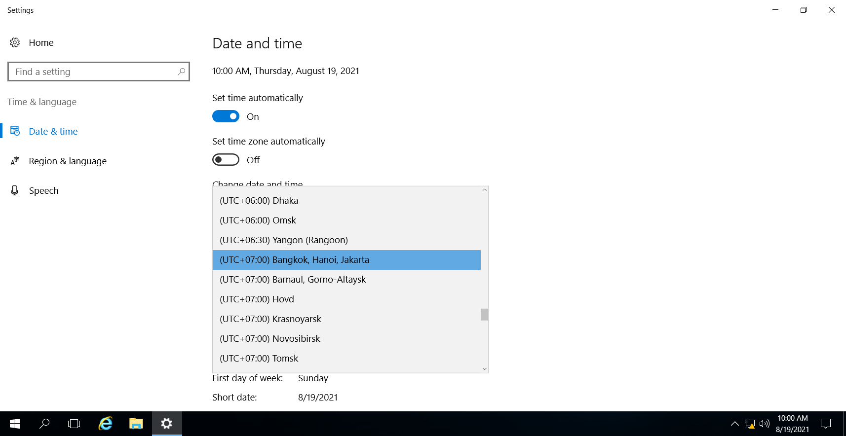

1. Enable automatic updates

Step 1: Go to Command Prompt run as administrator

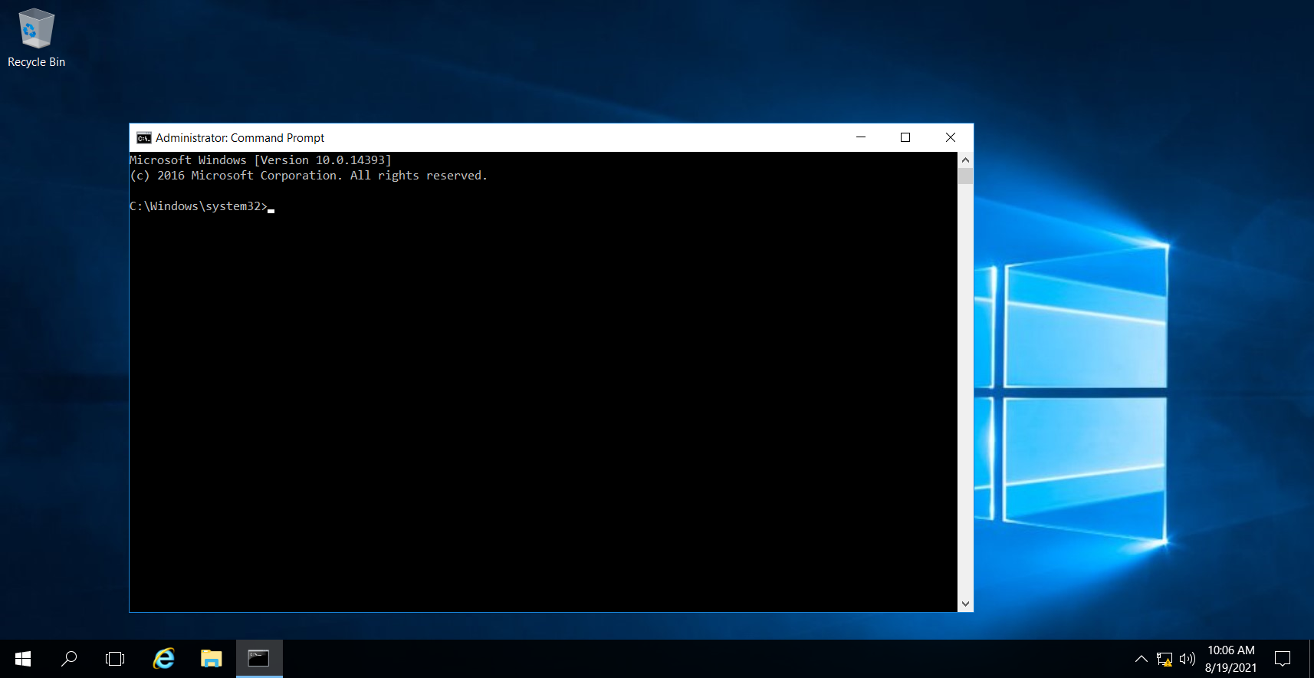

Step 2: Type **sconfig**

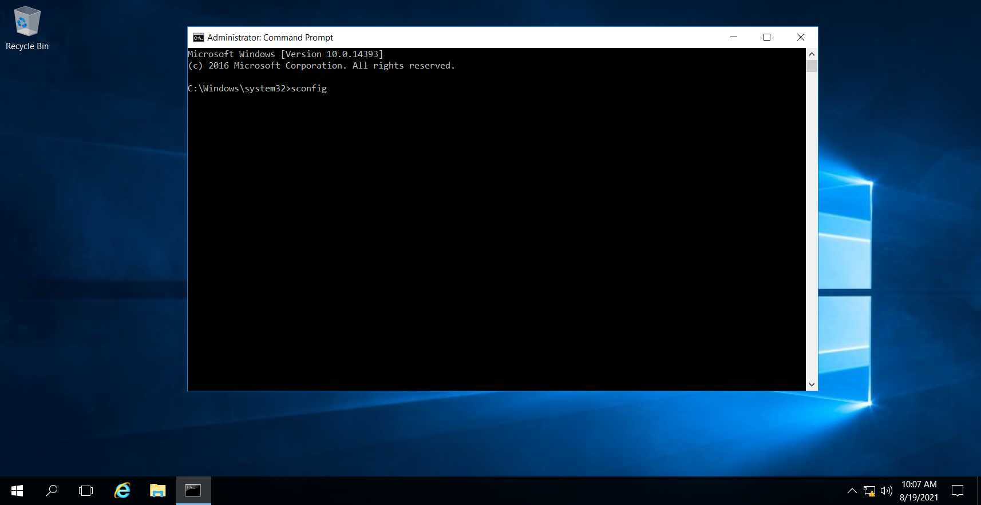

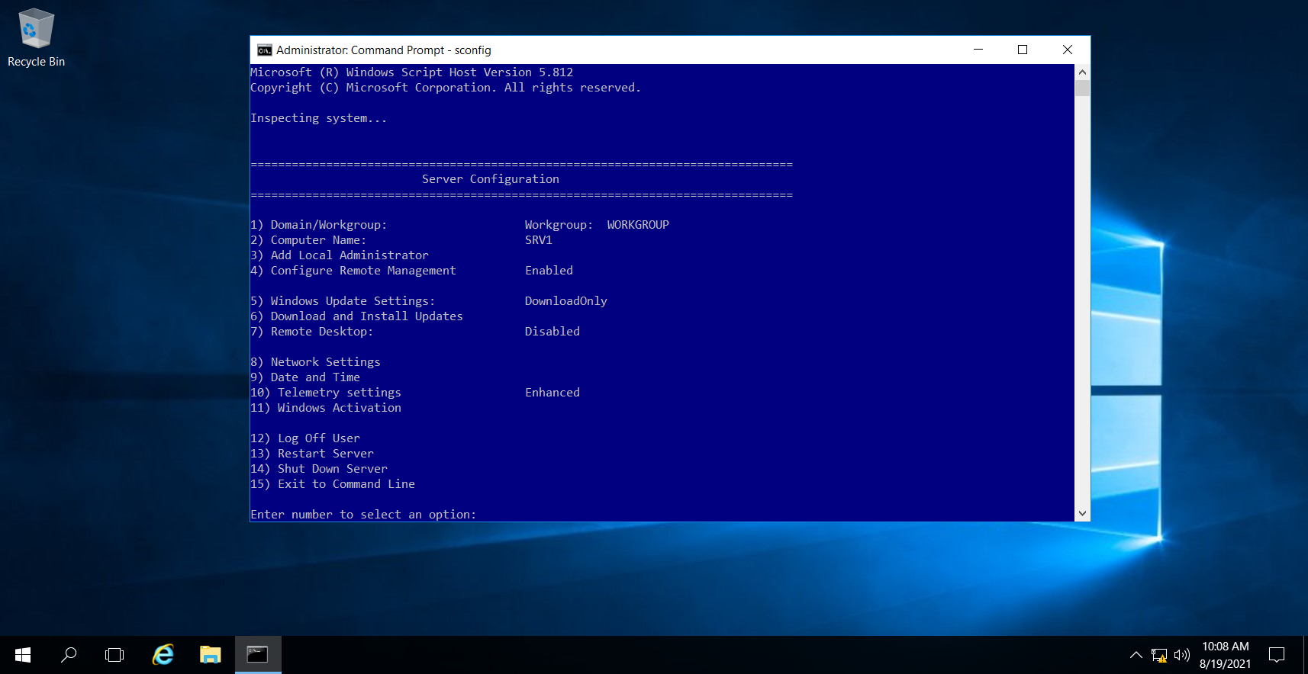

Step 3: Choose the Option 5.

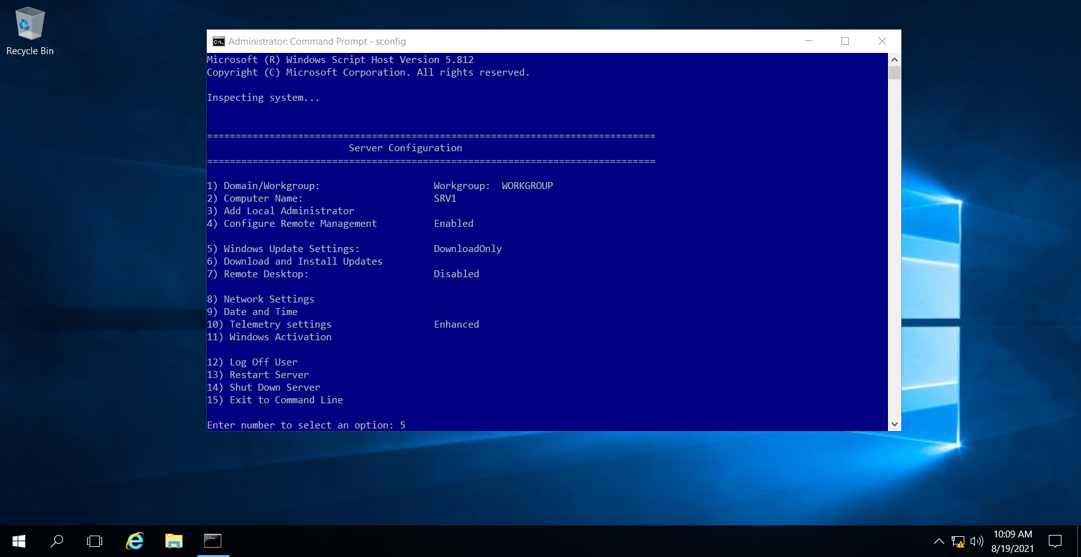

Step4: Type ‘A’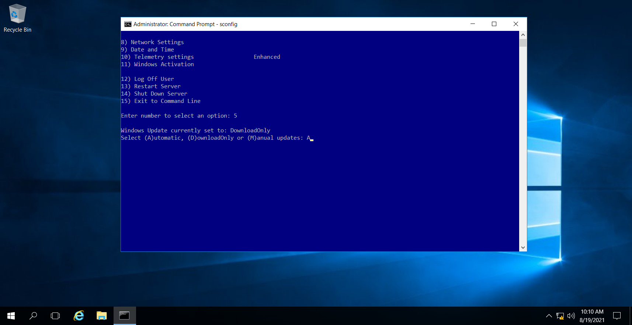

Step 5: Click OK

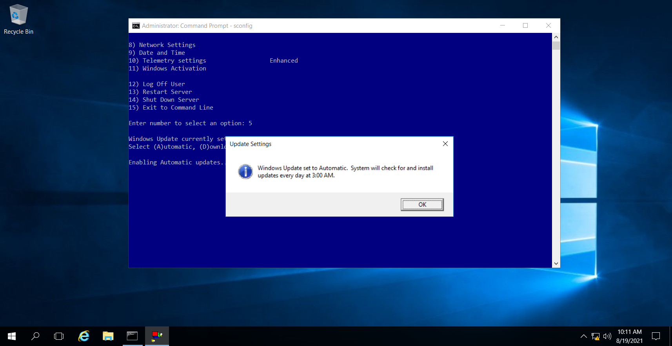

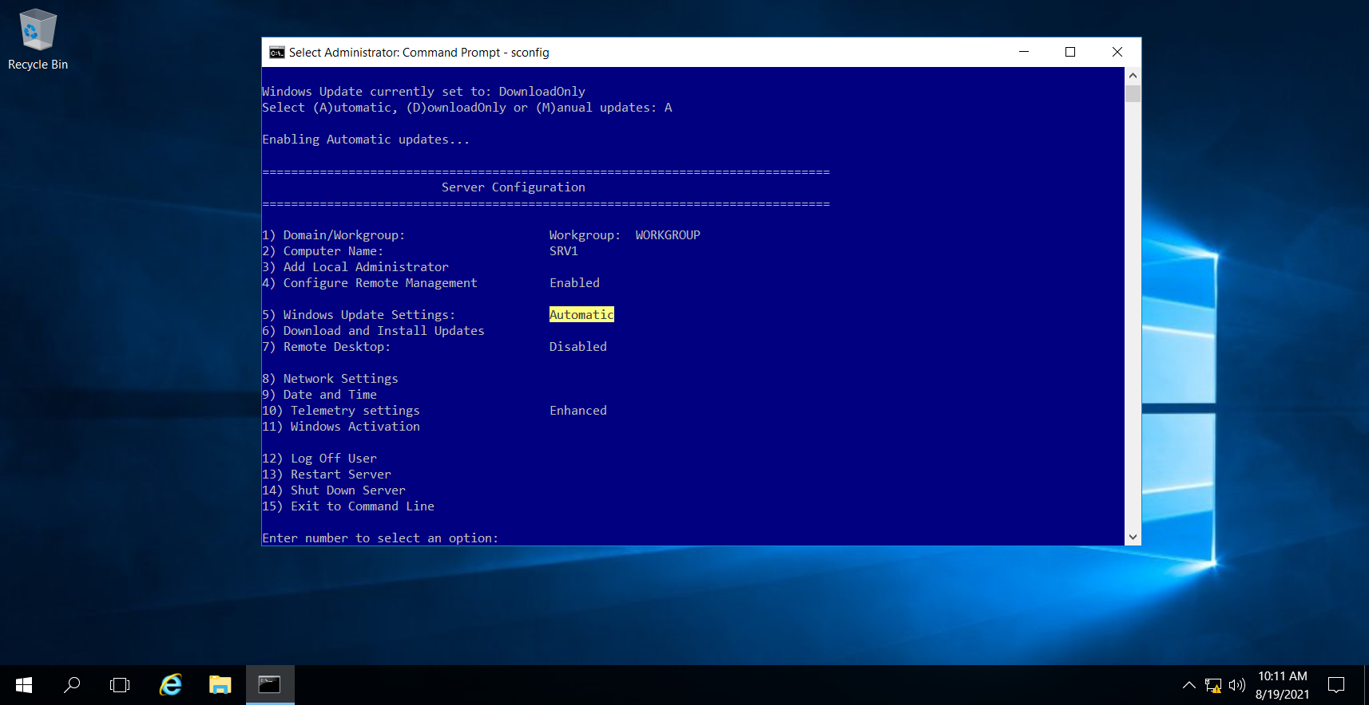

1. Enable the Remote Desktop feature



Step 1: Type ‘7’

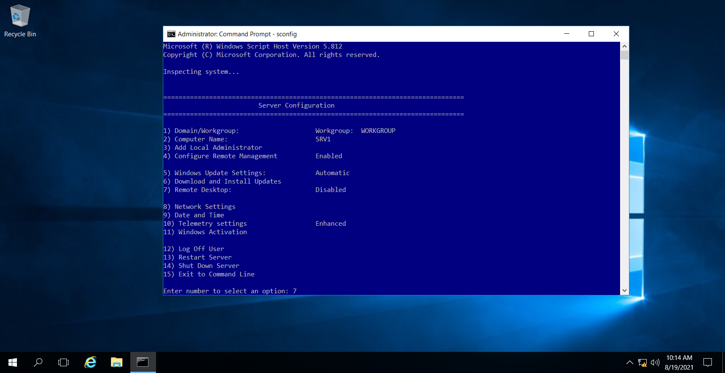

Step 2: result

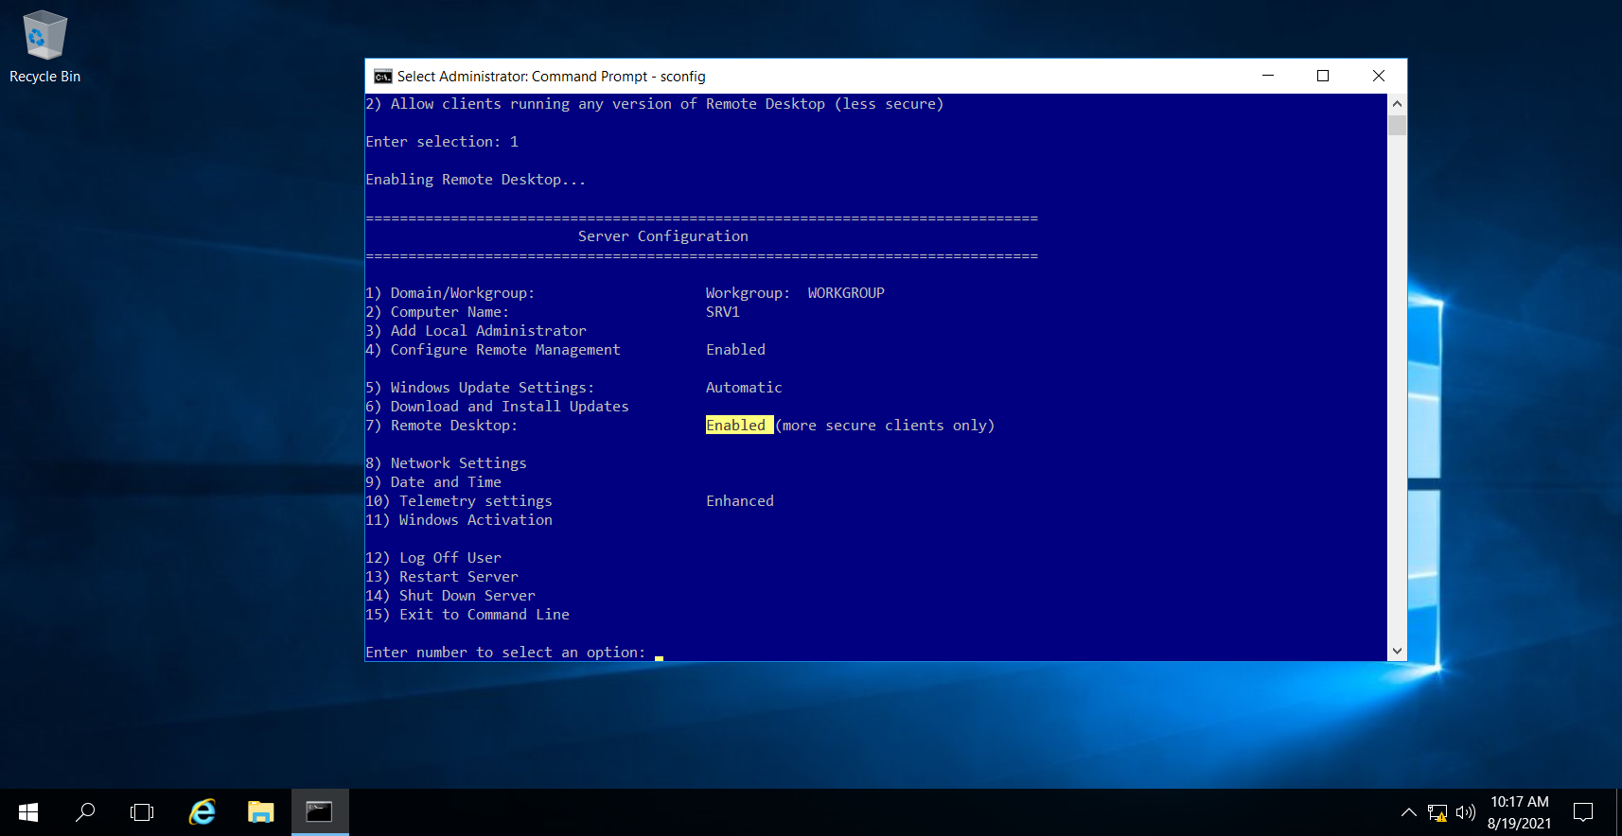

1. Configure Windows Firewall settings: Allow RDP

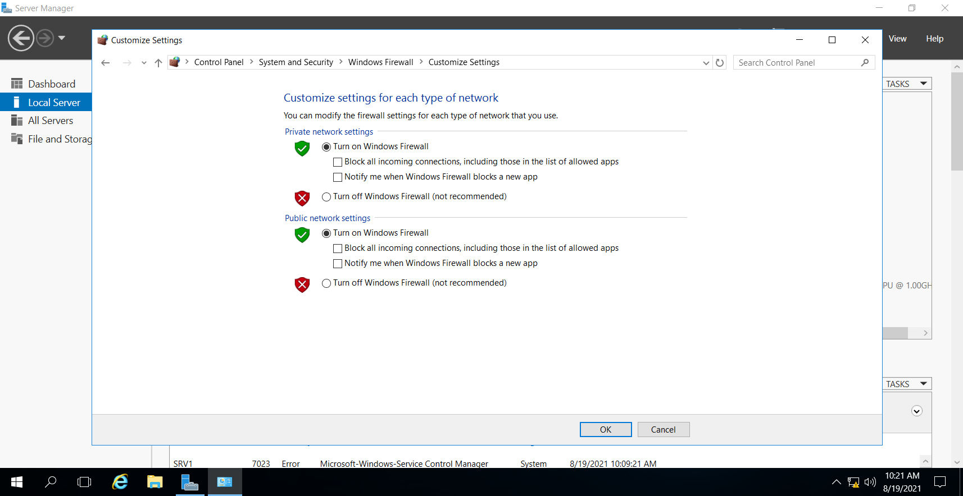

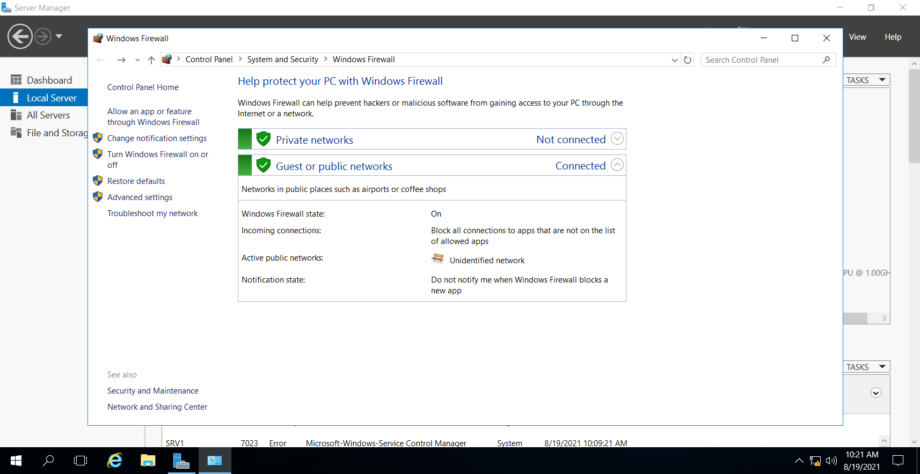

1. Implementing RAID 0, RAID 1

Step 1: Open Server Disk Management. Right-click one of the volumes on the dynamic disk and select the "Add Mirror".

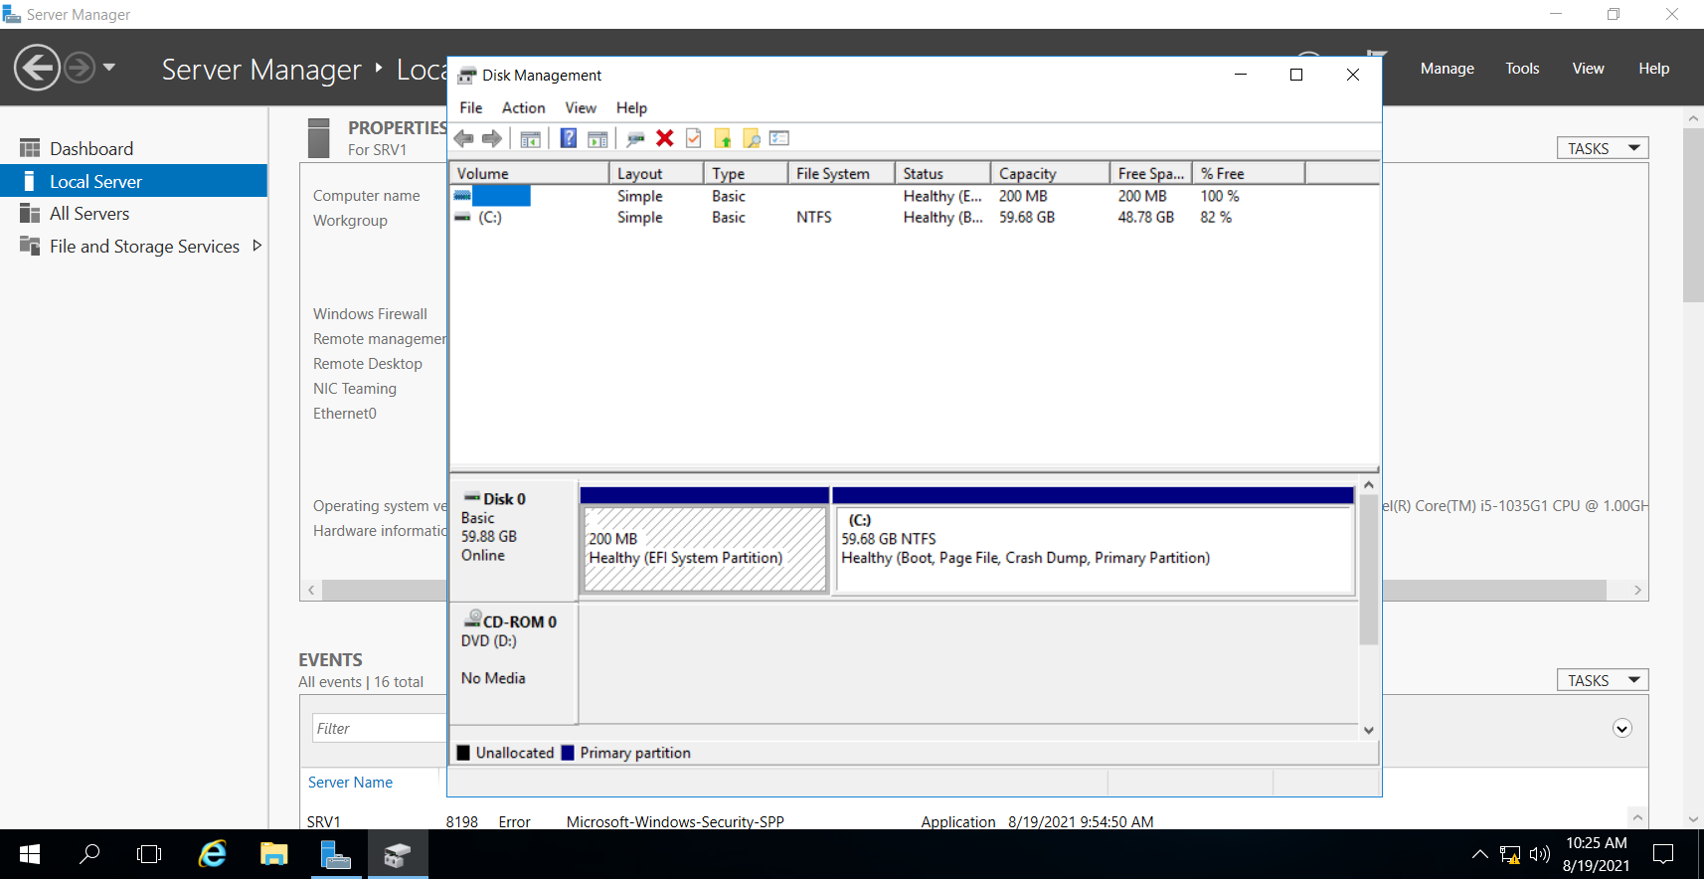

Step 2: Shrink volume

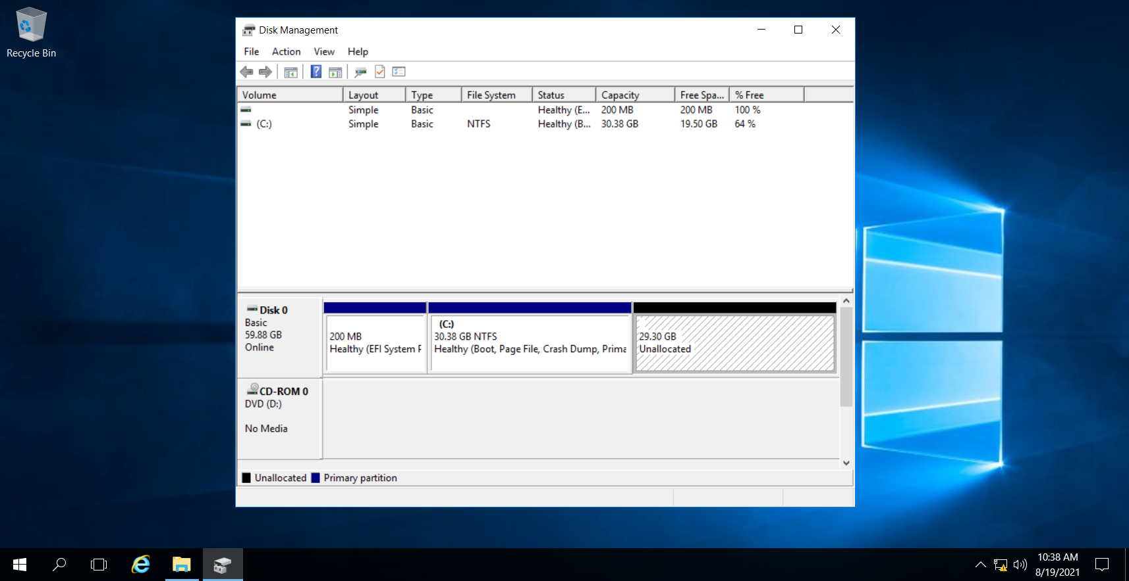

Result:

